Risk analysis of complex plants

Let's imagine a real case of deduction of the potential failures of a fluid transport system over long distances (water, gas, excrement, etc.).
The data sources could be disparate, but let's try to work without data from the field: the system is new or not digital, the history does not exist because it is managed in analogue and very expensive to digitize. Can a risk analysis of that plant be carried out without data?

Context images
As a starting point, we start with the geographical maps (images), which describe the morphology and composition of the land on which our pipes pass and our plants are located. Let's imagine being able to find maps accompanied by information on landslides, floods and other relevant events (annotated images). These data are open and often for each critical event there is georeferenced data that can help us determine potential exogenous sources of failures (external root causes).
The system/plant
Let's now move inside, let's consider the availability of plant diagrams in the form of technical drawings (images).
Thanks to hybrid techniques, which combine traditional algorithms and machine learning, examples of drawings of individual components can be explicitly generated from patents on a large scale, each labeled (engine, pump, valve, tank, etc.) and linked to its graphic representations identified with certainty. The result is a dataset built automatically, but with the quality and reliability of a "golden set".
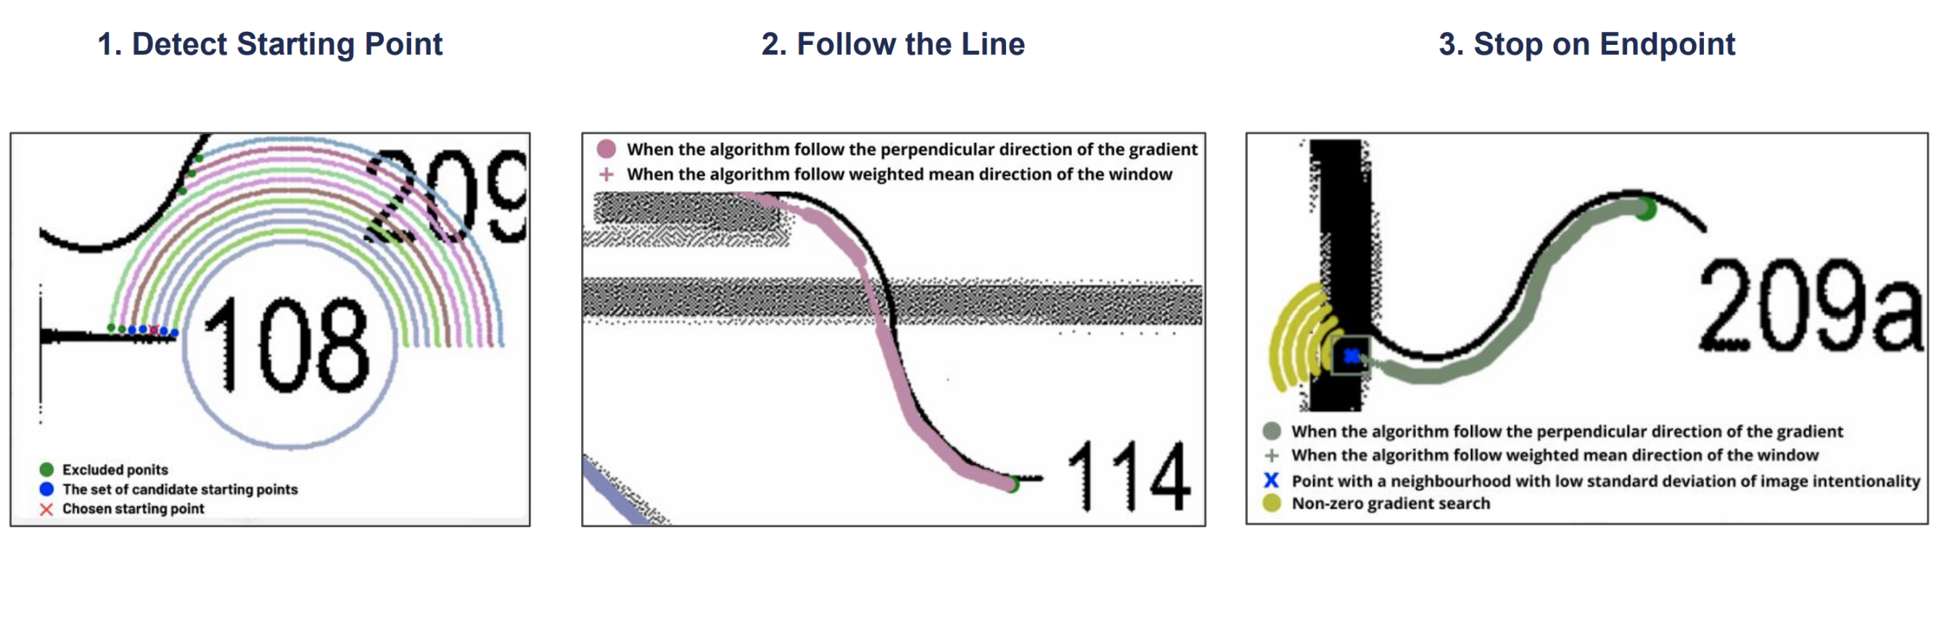
Result of a follow the line algorithm to identify components
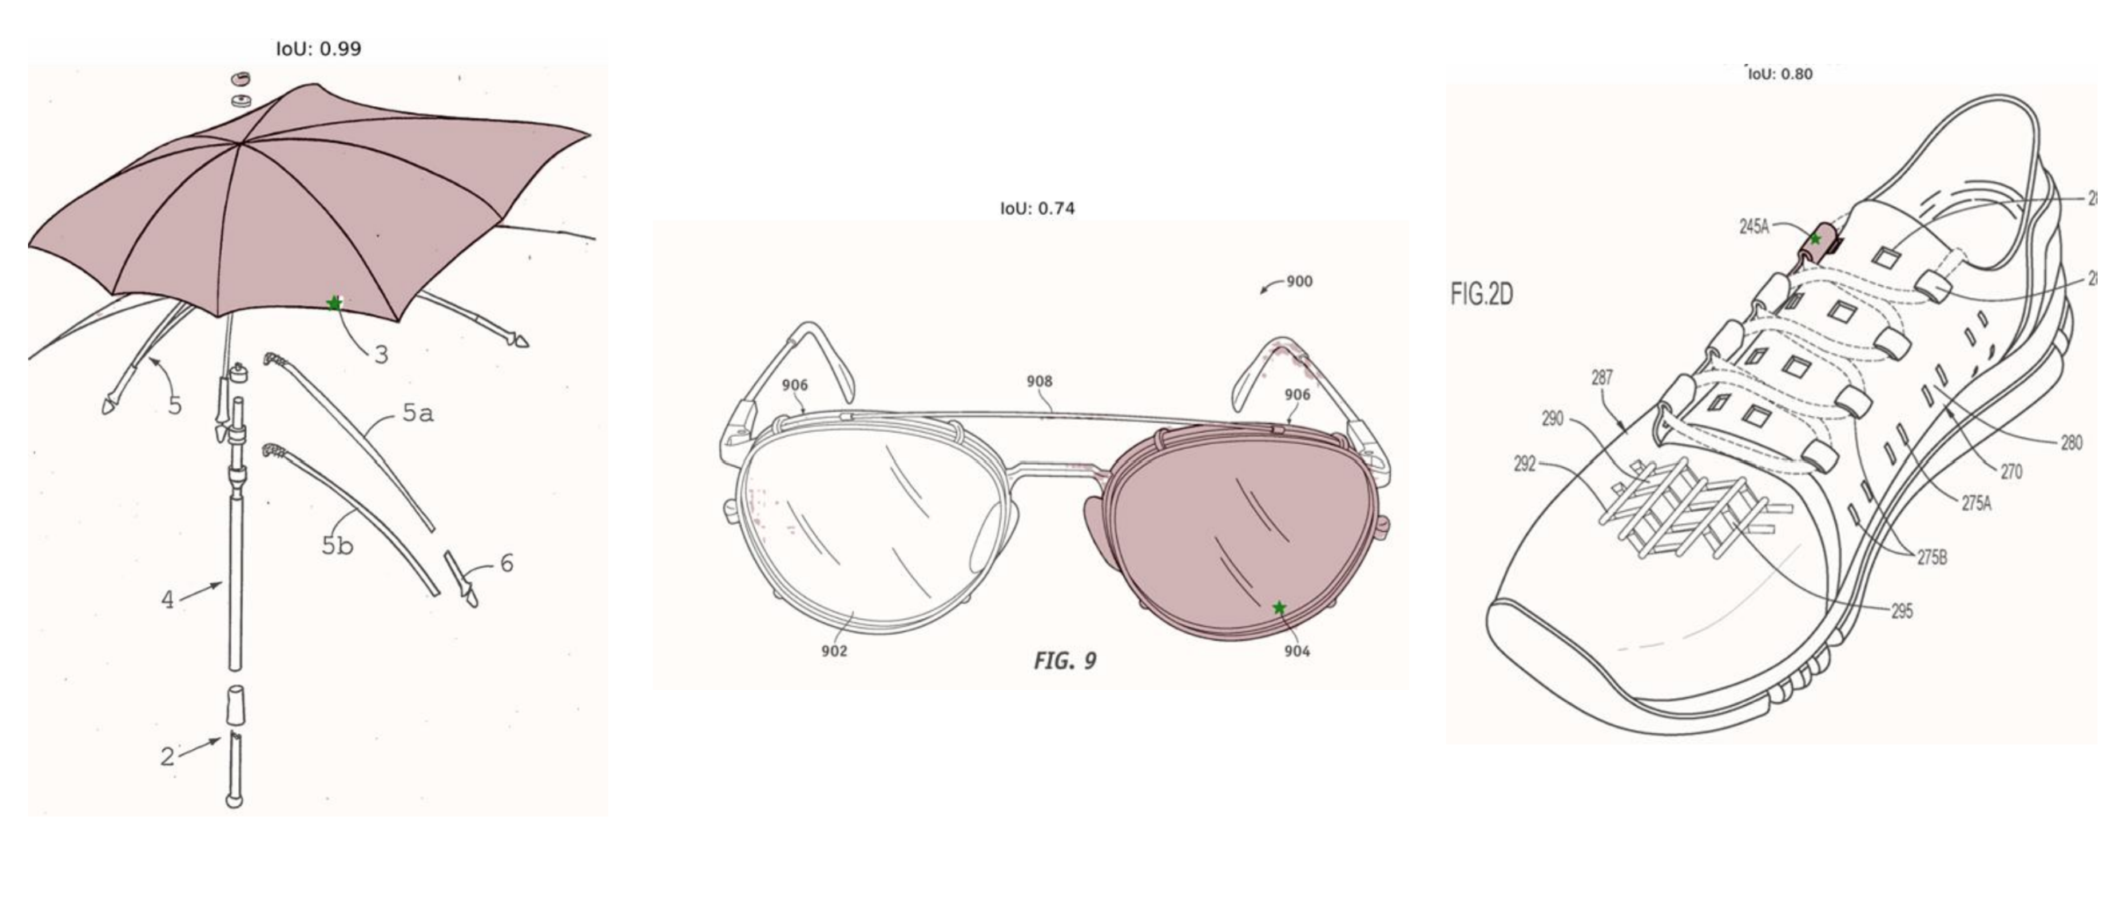
Follow the line algorithms plus segmentation systems

From plant drawings or 2D CADs, using image processing techniques or through the latest Visual Language Models, all the technical elements present in the diagram can be automatically extracted, together with the information contained in the title block and in the attached documents.
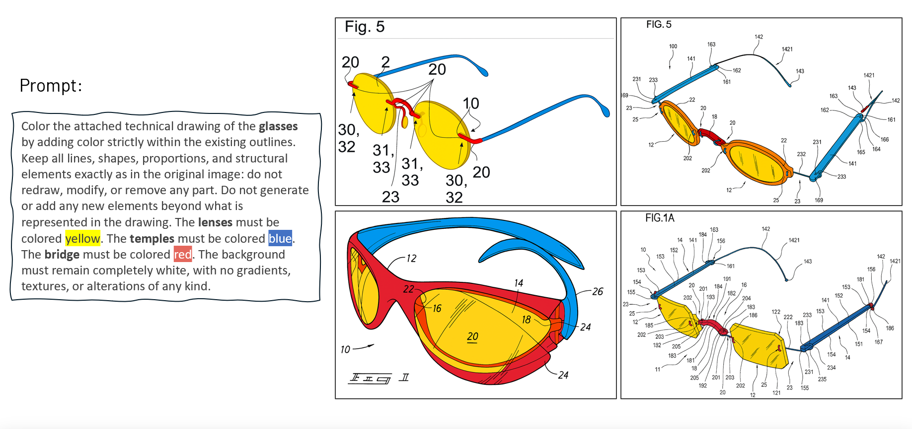
VLM at work
A similar approach can be applied to maps, exploiting methodologies developed for natural disaster prediction or precision agriculture. Convolutional neural networks (CNNs), for example, make it possible not only to correctly label the different areas crossed by the aqueduct, but also to identify, through spatial and temporal correlations, potential critical issues that are not yet manifest. Finally, the integration of geological, hydrogeological, urban planning and other data aggregated by competent bodies makes it possible to estimate the probability of rare but possible events, improving the overall predictive capacity of the system.
Components and their causes of failure
Now we need to move on to understanding how individual components (tanks, pumps, motors, pipes, valves, etc.) fail. Without data sources this could be a huge problem, but a heterodox source could help us. By analyzing the patents relating to the individual components, it is possible to extract the typical problems of each element, identifying the problems and solutions proposed in the patent texts. Problems represent potential failures or losses of ideality, to be mapped in our risk analysis or FMECA). During this phase, problem-solution pairs can also be synthesized: however, since a single problem often corresponds to many solutions, the result is a database with a one-to-many structure. This approach allows to select, among the solutions identified, the one most suitable for the specific boundary conditions or constraints of the system (often described in plain text in the text), in line with the information contained in the patents.

Even just by integrating these different information sources, it becomes possible to hypothesize a series of potential endogenous failures to the system and its components and estimate the probability of occurrence given the presence or absence of the boundary conditions.
The solution
To date, we have a system capable of combining the most recent part of the advancement on convolutional networks for images with transformer systems trained on patents and capable of extracting the quaternions component, problem, solutions, boundary conditions/constraints.
For each of these quaternions it is possible, given the scheme of the system transformed into a formal equivalent (with AND, OR, XOR), to estimate the impacts (severity) and the probability of failure. This is sufficient for a risk analysis. If the technical data sheets of each component and the "digital shadows" of the plant components are also available, it is also possible to estimate their detectability and have a complete FMECA, certainly not exact but estimated obtained automatically from scretch.

